Assignment-2

CraftaqueryusinganINNERJOINtocombine'orders'and'customers'tables forcustomersinaspecifiedregion,andaLEFTJOINtodisplayallcustomersincludingthose withoutorders.



Assignment2:

CustomerandOrderTableData

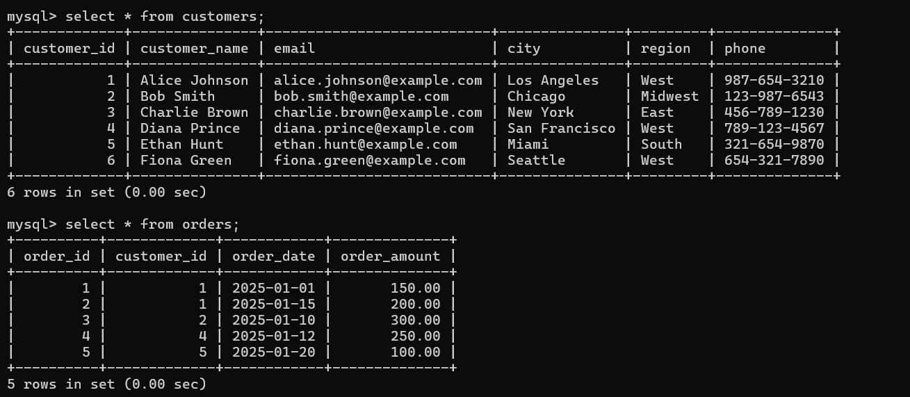

INNERJOINQueryforCustomersinaSpecificRegion

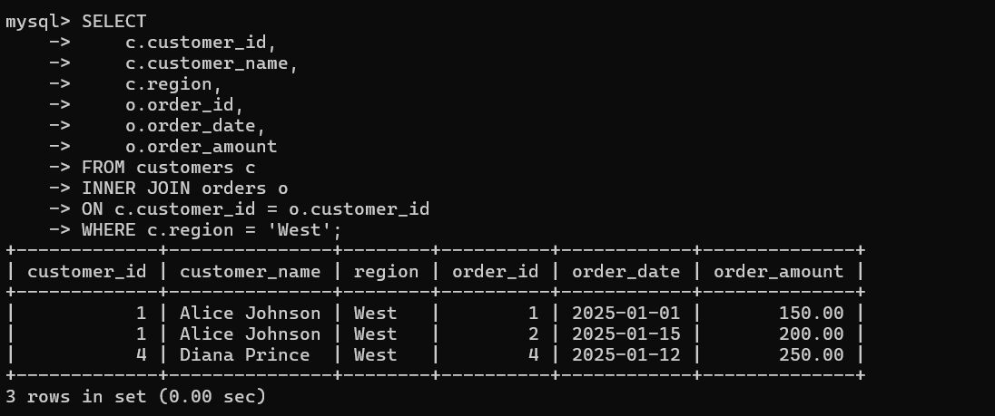

21958-Lokesh_Panem

LEFTJOINQuerytoDisplayAllCustomersIncludingThoseWithoutOrders

